ASSUMPTION CATEGORIES & QUESTIONS

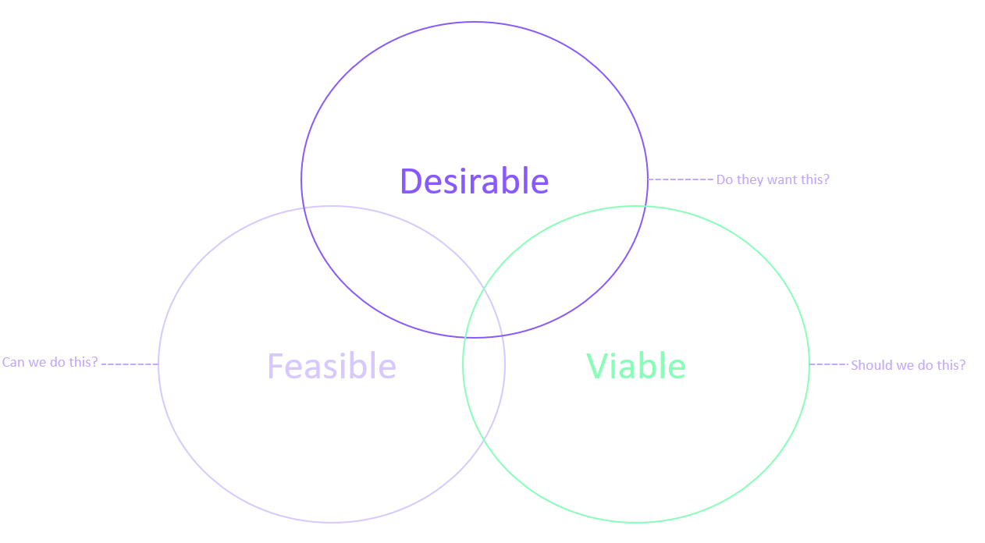

Assumptions are internal and/or external factors that have the potential to influence (or even determine) the success of an intervention but most often lie outside the direct control of the implementing team. Assumptions relating to key enablers for- and barriers to the intervention should be carefully identified, monitored, and acted upon to give the intervention the best possible conditions for success.

1. Desirability: Testing if the intended target group(s) want the concept/solution

To outline your team’s desirability assumptions, ask them the following questions:
- Who is/are the target group(s) for our solution?
- What problem does our target group want to solve?
- How do they solve this problem today?
- Why can’t they solve this problem today?
- What is the outcome our target group wants to achieve?
- Why will our target group stop using their current solution?

The participants should now discuss these questions and answer them as a team, writing their ”We believe that...” (WBT) responses on orange sticky notes:

- WBT the target group(s) for our solution is/are …
- WBT the problem our target group wants to solve is …
- WBT they solve this problem today by …
- WBT they can’t solve this problem today because …
- WBT the outcome they want to achieve is …
- WBT they will stop using their current solution because …

2. Viability: Testing whether you should implement the solution.
To outline your team’s viability assumptions, ask them the following questions:
- What is the entry point to the community we want to work with?
- Why will our target group(s) adopt our solution?
- Why will they share the solution with other community members?
- How does our solution interact and fit with other existing solutions?
- How does our solution interact and fit with other existing enabling systems?
- How does this solution support our programme and organisational strategies and plans?
- Who are the other actors trying to provide a similar solution?
- How will our solution lead to the desired impact?

The participants should now discuss these questions and answer them as a team, writing their ”We believe that...” (WBT) responses on green sticky notes:

- WBT the target community entry point is …
- WBT the target group(s) will adopt our solution because…
- WBT they will share the solution with others because …
- WBT our solution will interoperate with existing solutions by…
- WBT our solution will interoperate with existing systems by…
- WBT the solution supports our programme and organisational strategies and plans because…
- WBT the other actors trying to provide similar solutions are …
- WBT our solution will lead to the desired impact because…

3. Feasibility: Testing whether you can do it
To outline your team’s viability assumptions, ask them the following questions:
- What are our biggest technical (i.e., programmatic competences) challenges?
- What are our biggest legal or regulatory risks?
- What is our internal governance or policy hurdles?
- Why does our leadership team support this solution?
- Where does our funding for this solution come from and is it sustainable?
- Why is our team (uniquely) positioned to achieve impact?

Your team should discuss these questions and answer them as a team, writing their ”We believe that...” (WBT) responses on blue sticky notes:

- WBT our biggest technical challenges are …
- WBT our biggest legal and regulatory risks are…
- WBT our biggest internal governance and policy hurdles are…
- WBT our leadership team support this solution because…
- WBT the funding for this solution will come from…
- WBT our team is uniquely positioned to achieve impact because…

